

**LAB MANUAL**

**Academic Year-2023-24**

**Program: BTI Computer Engineering/ Data Science**

**Semester – III**

**Course: - Computer Hardware and Maintenance**

**LAB ASSISTANT FACULTY**

| **Course Faculties** | | | |
| --- | --- | --- | --- |
| **Course Faculty 1**  Dr. Seema Shah : | |  | |
| **Course Faculty 2** | | **Course Faculty 3** | |

**Lab Submission nomenclature:CHM_III_Div_RollNo**

**EXPERIMENT NO. 1**

**PART A**

**A.1 AIM: -**To get familiar with Computer System specifications

**A.2 Prerequisite**

Nil

**A.3 Outcome**

After successful completion of this experiment students will be able to

1. Understand various parts of the computer
2. List the specifications of a desktop/ laptop

**A.4 Theory**

To get familiar with Computer System specifications (Demo and Market Survey)

**Reading:** Reading manual - Chapter 1

**Task 1:**

Fill in the details in the following table after the demo:

**Table 1: Specification of Desktop PC**

| **Sr. No.** | **Part** | | | **Manufacturer** | **Specification** |
| --- | --- | --- | --- | --- | --- |
| 1 | Processor (CPU) | | |  |  |
| 2 | Operating System | | |  |  |
| 3 | Memory | | |  |  |
| 4 | Storage (Hard Disk) | | |  |  |
| 5 | Graphics Card | | |  |  |
| 6 | Display/Monitor | | |  |  |
| 7 | Hard Disk Drive | | |  |  |
| 8 | CD/DVD Drive | | |  |  |
| 9 | Keyboard | | |  |  |
| 10 | Mouse | | |  |  |
| 11 | Network Adaptor | | |  |  |
| 12 | HDMI / VGA Port | | |  |  |
| 13 | USB Ports | | |  |  |
| 14 | Card Reader | | |  |  |
| 15 | Any other | | |  |  |

**Table 2: Specification of Laptop**

| **Sr. No.** | **Part** | **Manufacturer** | **Specification** |
| --- | --- | --- | --- |
| 1 | Processor (CPU) |  |  |
| 2 | Operating System |  |  |
| 3 | Memory |  |  |
| 4 | Storage |  |  |
| 5 | Graphics Card |  |  |
| 6 | Display (LED/LCD) |  |  |
| 7 | Hard Disk Drive |  |  |
| 8 | CD/DVD Drive |  |  |
| 9 | Network Adapter |  |  |
| 10 | HDMI Port |  |  |
| 11 | USB Port |  |  |
| 12 | Wireless Network |  |  |
| 13 | Camera |  |  |
| 14 | Any other |  |  |

**Task 2:**

Label different parts of the Desktop Computer shown in Fig. 1

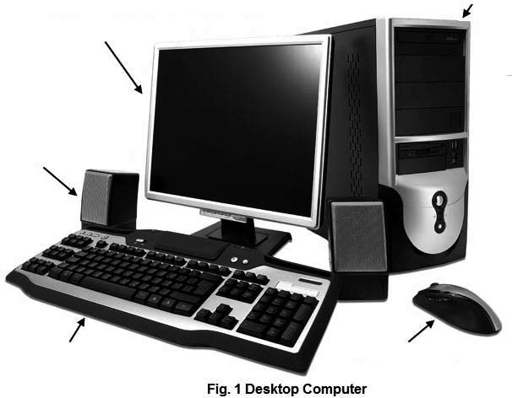

Label different parts of the Laptop shown in Fig. 2 in a slide.

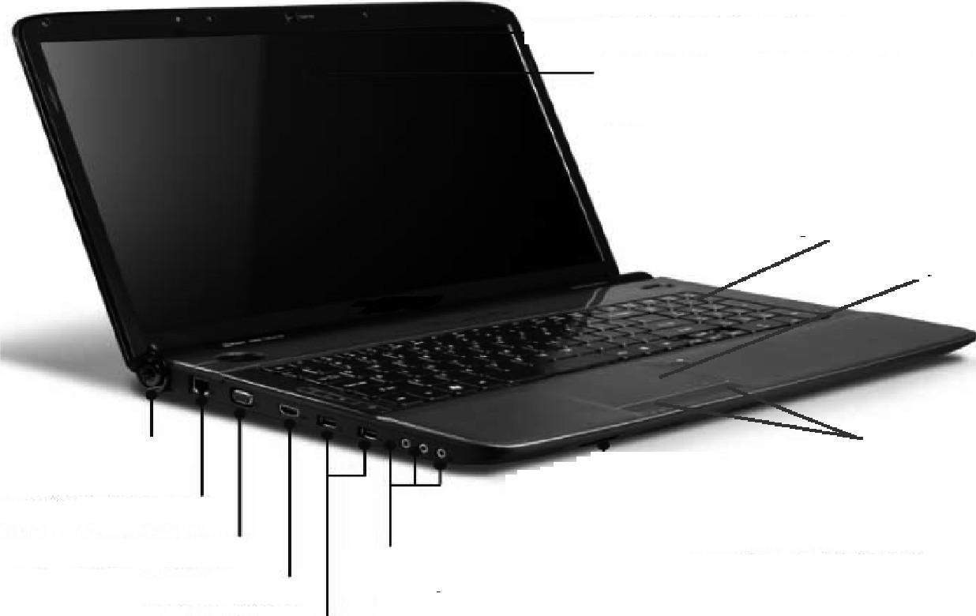

**Task 3:**

State the main function of each part of the computer that you have listed in table 1

**Task 4:**

Timeline of CPU :

For a specific manufacturer, illustrate the timeline of various generations of the CPU and the major difference in each generation. (last 5 generations)

**Task 5: (Practicum Segment)**

* Students need to go to the images below and select a mandatory component for Practicum.
* Every student needs to pick up a unique component

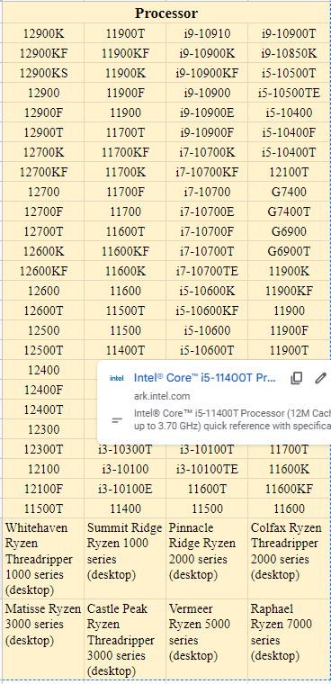

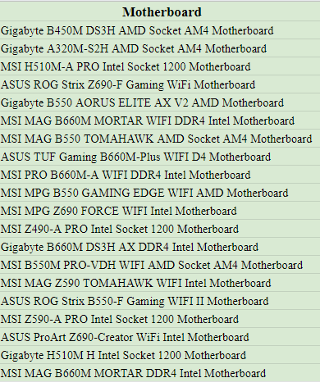

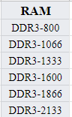

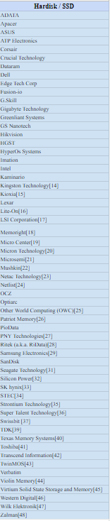

**PART B**

(PART B: TO BE COMPLETED BY STUDENTS)

**(Students must submit the soft copy as per following segments within two hours of the practical. The soft copy must be uploaded on the Blackboard or emailed to the concerned lab in charge faculties at the end of the practical in case the there is no Black board access available)**

| Roll No. | Name: |
| --- | --- |
| Program: | Division: |
| Semester | Batch : |
| Date of Experiment: | Date of Submission: |
| Grade : |  |

B.1 Submission written by student: **Table 1: Specification of Desktop PC**

**Table 2: Specification of Laptop**

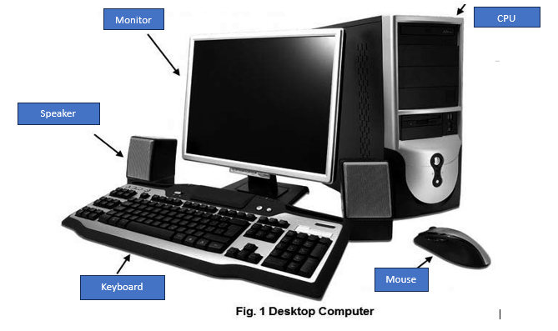  
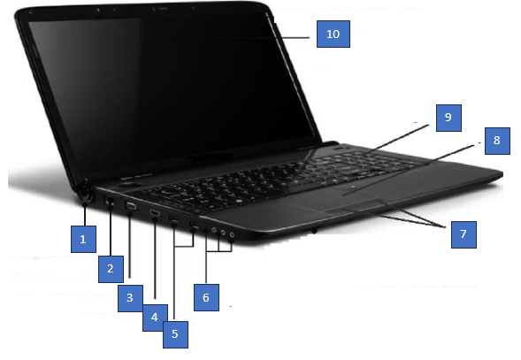

**Task 3**

B.2 Conclusion:

*(****Students must write the conclusion as per the attainment of individual outcome listed above and learning/observation noted in section B.1)***

**EXPERIMENT NO. 2**

**PART A**

**A.1 AIM: -** To assemble and Disassemble the Desktop PC and identify its parts (Demo)

**A.2 Prerequisite**

Nil

**A.3 Outcome**

After successful completion of this experiment students will be able to:

1. Assemble and Disassemble the Desktop PC and identify its parts
2. Understand the functioning in Server room

**A.4 Theory**

To assemble and Disassemble the Desktop PC and identify its parts (Demo)

**Video Link:** [How To Build A PC - Step by Step (Full Build Guide)](https://youtu.be/PXaLc9AYIcg)

Jot down important points you have learnt from the video.

**Task 1:**

1. Demo will be given to the students about the steps to assemble a PC
2. Students will assemble a PC in a group of 5 after the demo

**Task 2:**

Students will be taken for a server room tour / shown a video of the server room. The following table needs to be filled up after the tour:

| **Sr. No.** | **Part** | **Manufacturer** | **Specification** |
| --- | --- | --- | --- |
| 1 | Server Type |  |  |
| 2 | Processor (CPU) |  |  |
| 3 | Nos. of Processors |  |  |
| 4 | Memory-RAM |  |  |
| 5 | Cache Memory (L1  and L2) |  |  |
| 6 | Hard Disk Drive |  |  |
| 7 | Hard Drives Supported  (IDE/SCSI) |  |  |
| 8 | Network Adapter |  |  |
| 9 | Firewire Port |  |  |
| 10 | USB Port |  |  |
| 11 | Wireless |  |  |
| 12 | Operating System |  |  |
| 13 | CD/DVD Drive |  |  |

**Task 3**:

Prepare a detailed technical report of the visit to the server room.

**PART B**

(PART B: TO BE COMPLETED BY STUDENTS)

**(Students must submit the soft copy as per following segments within two hours of the practical. The soft copy must be uploaded on the Blackboard or emailed to the concerned lab in charge faculties at the end of the practical in case the there is no Black board access available)**

| Roll No. | Name: |
| --- | --- |
| Program: | Division: |
| Semester: | Batch : |
| Date of Experiment: | Date of Submission: |
| Grade : |  |

B.1 Submission written by student:

| **Sr. No.** | **Part** | **Manufacturer** | **Specification** |
| --- | --- | --- | --- |
| 1 | Server Type |  |  |
| 2 | Processor (CPU) |  |  |
| 3 | Nos. of Processors |  |  |
| 4 | Memory-RAM |  |  |
| 5 | Cache Memory (L1  and L2) |  |  |
| 6 | Hard Disk Drive |  |  |
| 7 | Hard Drives Supported  (IDE/SCSI) |  |  |
| 8 | Network Adapter |  |  |
| 9 | Firewire Port |  |  |
| 10 | USB Port |  |  |
| 11 | Wireless |  |  |
| 12 | Operating System |  |  |
| 13 | CD/DVD Drive |  |  |

B.2 Conclusion:

*(****Students must write the conclusion as per the attainment of individual outcome listed above and learning/observation noted in section B.1)***

**EXPERIMENT NO. 3**

**PART A**

**A.1 AIM: -**To configure BIOS setup program and troubleshoot the problems using BIOS utility

**A.2 Prerequisite**

Nil

**A.3 Outcome**

After successful completion of this experiment students will be able to:

1. Configure BIOS setup program
2. Troubleshoot the problems using BIOS utility

**A.4 Theory**

To configure BIOS setup program and troubleshoot the problems using BIOS utility (Handson)

**Reading:** Reading Manual Page 26 - 49

**Task 1:**

Follow the following steps to enter the BIOS Setup Program utility:

1. Power ON the computer.
2. After power On, a black screen appears on your monitor, wait until the message appears briefly at the bottom of the screen such as "Press F2 to enter SETUP, F12 for Network Boot, ESC for Boot Menu"
3. Now press the F2 key to enter the setup program. (This key may vary from one machine to another machine depending on the manufacturer of the BIOS Setup program)
4. Observe different BIOS setups.

**Task 2:**

1. List cache type, size and memory size of the system from Main setup.
2. State any two setting under CPU configuration.
3. Write down boot devices priority in boot sequence menu as follows:

1st Boot Device:

2nd  Boot Device:

3rd Boot Device:

**Task 3:**

1. Explain in detail what is BIOS?
2. What are the various functions of BIOS?
3. Explain in detail different types of BIOS.

**PART B**

(PART B: TO BE COMPLETED BY STUDENTS)

**(Students must submit the soft copy as per following segments within two hours of the practical. The soft copy must be uploaded on the Blackboard or emailed to the concerned lab in charge faculties at the end of the practical in case the there is no Black board access available)**

| Roll No. C131 | Name: Vihaan Sheth |
| --- | --- |
| Program: BTI | Division: D1 |
| Semester: 3 | Batch : D |
| Date of Experiment: | Date of Submission: |
| Grade : |  |

B.2 Conclusion:

*(****Students must write the conclusion as per the attainment of individual outcome listed above and learning/observation noted in section B.1)***

**EXPERIMENT NO. 4**

**PART A**

**A.1 AIM: -** To troubleshoot the Hard disk (Handson)

**A.2 Prerequisite**

Nil

**A.3 Outcome**

After successful completion of this experiment students will be able to understand

1. Troubleshooting of Hard disk
2. Virus threat
3. Reason for slow performance of Hard disk and to rectify it.

**A.4 Theory**

* **Video Link:** [How to Troubleshoot Your Hard Drive](https://www.youtube.com/watch?v=yyEZotOPQJc)
* Keyboard - [How to Fix Laptop Keyboard Not Working | Windows 11, 10, 8, 7](https://www.youtube.com/watch?v=HFgNbJl7gSo)
* Mouse - [How To Fix USB Mouse Not Working on Windows 10](https://www.youtube.com/watch?v=_DPIAuWxVLk)
* **Reading: Reading Manual Chapter 2**

**Task 1:**

**Follow the steps for Troubleshooting Harddisk**

1. **Corrupted files on hard disk:** Avoid installing suspected software and malicious programs into your hard disk. Clean the hard disk on a regular basis to remove unwanted programs. Use Disk Clean up utility in windows.

**To open Disk Clean up on a Windows follow these instructions:**

a. Click Settings > Click Control Panel > Administrative Tools.

b. Click Disk Clean up.

c. At the Drives list, select which drive you want to run Disk Clean up on.

d. Select which files you want to delete.

e. Click OK.

f. Click delete files.

2. **Virus threat:** Students should practice scanning and malware detection with available antivirus S/W. Update the anti-virus program

3. **Slow performance of Hard disk:**

Steps to be followed for Defragmentation with Windows:

a. Open the Computer window.

b. Right-click the media you want to defragment, such as the main hard drive, C.

c. In the drive's Properties dialog box, click the Tools tab.

d. Click the Defragment Now button.

e. The Disk Defragmenter window appears. Click the Analyse Disk button. Wait while Windows checks the defragmentation on the media.

f. Check the Percent Fragmented value by the disk in the Disk Defragmenter window. If it's zero, there's no point in continuing: Skip to Step 8.

g. Even when the drive shows O percent fragmented files, you can still proceed with defragmentation. No media can be fully defragmented, so the Windows Defragmenter will always find something to do.

h. Click the Defragment Disk button.

1. Windows defragments the media. You shouldn't do anything on your computer while the media is being defragmented.

J. Click the Close button, and close up any other windows you opened.

**Task 2:**

1. What happens when a hard disk fails?
2. What is the defragmentation process?
3. How data is read and written on a hard disk.
4. What is the role of antivirus software and how it protects our computer?
5. What are the various sources of computer virus?

**PART B**

(PART B: TO BE COMPLETED BY STUDENTS)

**(Students must submit the soft copy as per following segments within two hours of the practical. The soft copy must be uploaded on the Blackboard or emailed to the concerned lab in charge faculties at the end of the practical in case the there is no Black board access available)**

| Roll No. C131 | Name: Vihaan Sheth |
| --- | --- |
| Program: BTI | Division: D1 |
| Semester: 3 | Batch : D |
| Date of Experiment: | Date of Submission: |
| Grade : |  |

B.2 Conclusion:

*(****Students must write the conclusion as per the attainment of individual outcome listed above and learning/observation noted in section B.1)***

**EXPERIMENT NO. 5**

**PART A**

**A.1 AIM: -** To study the maintenance of Computer processors(Demo, Handson)

**A.2 Prerequisite**

Nil

**A.3 Outcome**

After successful completion of this experiment students will be aware of

* Application of Thermal paste

**A.4 Theory**

**Reading: Reading Manual Chapter 2**

**Task 1:**

A demo will be given to students about the application of thermal paste and how it works. Students need to observe it carefully and note down the important points

**Task 2:**

Students will be assigned a task to take out the heat sync and apply thermal paste to the processor in a group of 5

**Task 3:**

# What is Thermal Paste and how does it keep your processor cool?

1. What happens if you don't use thermal paste on a CPU?
2. What are the benefits of thermal paste on CPU?
3. How do I know if my CPU needs thermal paste?
4. What is the lifespan of Thermal paste?

**PART B**

(PART B: TO BE COMPLETED BY STUDENTS)

**(Students must submit the soft copy as per following segments within two hours of the practical. The soft copy must be uploaded on the Blackboard or emailed to the concerned lab in charge faculties at the end of the practical in case the there is no Black board access available)**

| Roll No. | Name: |
| --- | --- |
| Program: | Division: |
| Semester: | Batch : |
| Date of Experiment: | Date of Submission: |
| Grade : |  |

B.1 Submission written by student:

B.2 Conclusion:

*(****Students must write the conclusion as per the attainment of individual outcome listed above and learning/observation noted in section B.1)***

**EXPERIMENT NO. 6**

**PART A**

**A.1 AIM: -** To install and troubleshoot printer.

**A.2 Prerequisite**

Nil

**A.3 Outcome**

After successful completion of this experiment students will be able to install printer with various modes like using CD, drivers

**A.4 Theory**

**Reading Manual Chapter 3**

**Task 1:**

**Steps to install printer:**

1. Plug the power supply cable to the printer properly.

2. Plug the Data cable to the printer and PC port such as USB or parallel.

3. Press the Power button to turn on the printer and the power light comes on.

4. Put some papers in the paper tray/drawer.

**Way 1: Installing a plug and play printer**

a. If the printer is plug and play device, connect it and power it on; Windows Operating System installs device driver automatically if printer device driver is in-built in Windows Operating System.

b. If the printer device driver is not in-built in Windows Operating System then insert the disk that came with the printer and follow the on-screen instructions.

c. Test the printer to make sure it is working.

**Way 2: Installing a printer using the CD**

a. Second way of installation is to insert the CD that came with the printer.

b. If the CD does not automatically start, open "My Computer", double-click on the CD drive, and then click the Setup or Install file.

c. Follow the installation wizard and once completed your software is installed.

d. Test the printer to make sure it is working.

**Way 3: Installing a printer only using the drivers**

(If you only want the printer to be installed without extra software application programs, you can only install the printer driver by following the steps below.)

a. With the printer connected and ON, open the "Control Panel".

b. In the Control Panel double-click the Printers or Printers and Fax icon .

c. In the Printers window, click the Add a printer icon.

d. After completing the above steps, you should see the Windows Printer Wizard. Click Next to start the wizard.

e. Next, you have the choice of installing a Local or Network printer. If the printer is connected to the computer choose Local printer attached to this computer and click Next.

f. When prompted for the location of the printer drivers, browse to the directory of printer drivers or point it to the printer CD

**Task 2:**

After the printer is installed, you can use Windows to print a self-test page to verify the printer is working.

1. Click "Start", Settings, and open "Control Panel".

2. Double-click the "Printers or Printers and Fax icon".

3. Right-click on the Printer you want to test and click "Properties". If you do not see your printer, your printer is not installed .

4. In the "Printers Properties" window, click the "Print Test Page" button.

5. If the printer can print a test page, your printer is installed and set up properly.

Sharing the printer:

After the printer is installed, you can share a printer in the network if your PC is connected in the network.

1. Click "Start", Settings, and open "Control Panel".

2. Double-click the "Printers or Printers and Fax icon".

3. Right-click on the Printer you want to share and click "Sharing". If you do not see your printer, your printer is not installed.

4. In the "Sharing" window, Check the box that says "Share this printer"-=-

5. Then, you can edit the share name of the printer, in case you don't want to use the default

name provided by Windows.

6. When done, click OK.

7. The printer is now shared with the other computers on your network, regardless of the operating systems they are using

**Task 3:**

1. If you do not have any indicator light, make sure the printer is connected to a working power outlet by verifying each end of the power cable.

2. If the indicator is blinking or is orange, often this is an indication of a printer error, like a paper jam or an issue with the ink or toner cartridge. Remove the panel and carefully pull out the jammed paper.

3. No paper or paper jam -without paper, your printer will not be able to print. Make sure you have paper loaded into the printer paper cartridge or tray.

**Task 4:**

1. When a new printer is plugged in, what new needs to be installed?
2. Explain any 3 types of printers in detail.
3. What ports are available to be used when installing a printer?
4. What are the main parts of the printer?
5. Write the value or range of values for the following terms w.r.t to printer

* Amps
* Watts
* Unit
* Speed
* Frequency

**PART B**

(PART B: TO BE COMPLETED BY STUDENTS)

**(Students must submit the soft copy as per following segments within two hours of the practical. The soft copy must be uploaded on the Blackboard or emailed to the concerned lab in charge faculties at the end of the practical in case the there is no Black board access available)**

| Roll No. | Name: |
| --- | --- |
| Program: | Division: |
| Semester: | Batch : |
| Date of Experiment: | Date of Submission: |
| Grade : |  |

B.1 Submission written by student:

B.2 Conclusion:

*(****Students must write the conclusion as per the attainment of individual outcome listed above and learning/observation noted in section B.1)***

**EXPERIMENT NO. 7**

**PART A**

**A.1 AIM: -** To install and configure Scanner, Webcam and biometric devices with the system and troubleshoot the problems (Demo)

**A.2 Prerequisite**

Nil

**A.3 Outcome**

After successful completion of this experiment students will be able to

* Install and configure scanner, webcam and biometric devices with the system
* Troubleshoot the problem

**A.4 Theory**

**Reading Manual Chapter 3**

**Task 1:**

1. Plug your web camera or scanner into your computer.
2. If your camera is Plug and Play, the Scanner and Camera Wizard starts
3. Double-click Add Device.
4. Follow the instructions on your screen.

**Task 2:**

1. What are the benefits of biometrics?
2. Write the full form of scanner, its uses and importance.
3. How can I ensure that the footage is protected and only accessible by authorized parties?
4. How will the webcamera's data be stored and protected?
5. How will you secure the webcamera against physical tampering or hacking?

**PART B**

(PART B: TO BE COMPLETED BY STUDENTS)

**(Students must submit the soft copy as per following segments within two hours of the practical. The soft copy must be uploaded on the Blackboard or emailed to the concerned lab in charge faculties at the end of the practical in case the there is no Black board access available)**

| Roll No. | Name: |
| --- | --- |
| Program: | Division: |
| Semester: | Batch : |
| Date of Experiment: | Date of Submission: |
| Grade : |  |

B.1 Submission written by student:

B.2 Conclusion:

*(****Students must write the conclusion as per the attainment of individual outcome listed above and learning/observation noted in section B.1)***

**EXPERIMENT NO. 8**

**PART A**

**A.1 AIM: -** To observe various cables and connectors used in networking (Demo)

**A.2 Prerequisite**

Nil

**A.3 Outcome**

After successful completion of this experiment students will be aware of

**A.4 Theory**

**Reading Manual Chapter 3**

**Task 1:**

Students will be given a demo about the following components:

* RJ-45 connector
* IO Connector
* Crimping Tool
* Twisted-pair Cable
* Cable Tester

**Task 2:**

1. Remove the outmost vinyl shield for 12mm at one end of the cable (we call this side A-side).
2. Arrange the metal wires in parallel
3. Insert the metal wires into RJ45 connector on keeping the metal wire arrangement
4. Set the RJ45 connector (with the cable) on the pliers, and squeeze it tightly.
5. Make the other side of the cable ( B-side) in the same way.

**Task 3:**

Testing the crimped cable using a cable tester:

* Step 1 : Skin off the cable jacket 3.0 cm long cable stripper up to cable
* Step 2: Untwist each pair and straighten each wire 190 0 1.5 cm long.
* Step 3 : Cut all the wires
* Step 4 : Insert the wires into the RJ45 connector right white orange left brown the pins facing up
* Step 5 : Place the connector into a crimping tool, and squeeze hard so that the handle reaches its full swing.
* Step 6: Use a cable tester to test for proper continuity

Task 4:

1. List various types of Computer Cables and explain them in detail.
2. What is the difference between a cable and a connector?
3. What type of cable is used in most networks? Explain it.
4. Which is a faster networking cable?
5. Write the function of RJ-45 connector and Twisted-pair Cable?

**PART B**

(PART B: TO BE COMPLETED BY STUDENTS)

**(Students must submit the soft copy as per following segments within two hours of the practical. The soft copy must be uploaded on the Blackboard or emailed to the concerned lab in charge faculties at the end of the practical in case the there is no Black board access available)**

| Roll No. | Name: |
| --- | --- |
| Program: | Division: |
| Semester: | Batch : |
| Date of Experiment: | Date of Submission: |
| Grade : |  |

B.1 Submission written by student:

B.2 Conclusion:

*(****Students must write the conclusion as per the attainment of individual outcome listed above and learning/observation noted in section B.1)***

**EXPERIMENT NO. 9**

**PART A**

**A.1 AIM: -** To install SMPS and measure voltage levels in connectors of SMPS (Demo)

**A.2 Prerequisite**

Nil

**A.3 Outcome**

After successful completion of this experiment students will be aware of

**A.4 Theory**

**Reading Manual Chapter 4**

**Task 1:**

1. Connect the main AC supply to SMPS and switch ON.
2. Check voltage levels in all connectors of SMPS using digital multimeter
3. Note all voltage levels in the Observation table given below.
4. If voltage levels of all connector are correct, then switch OFF the power supply

**Task 2:**

Write down the different voltage levels observed in Table given below:

| **Pin No** | **Wire Color** | **Output Voltage** |
| --- | --- | --- |
|
| 1 | Orange |  |
| 2 | Orange |  |
| 3 | Black |  |
| 4 | Red |  |
| 5 | Black |  |
| 6 | Red |  |
| 7 | Black |  |
| 8 | Gray |  |
| 9 | Purple |  |
| 10 | Yellow |  |
| 11 | Yellow |  |
| 12 | Orange |  |
| 13 | Orange |  |
| 14 | Blue |  |
| 15 | Black |  |
| 16 | Green |  |
| 17 | Black |  |
| 18 | Black |  |
| 19 | Black |  |
| 20 | White |  |
| 21 | Red |  |
| 22 | Red |  |
| 23 | Red |  |
| 24 | Black |  |

**Task 3:**

1. Write wattage of given SMPS.
2. What are the applications of SMPS?
3. What are the main parts of SMPS?
4. What is the voltage of SMPS?Which capacitor and switch is used in SMPS?
5. How does SMPS convert AC to DC?

**PART B**

(PART B: TO BE COMPLETED BY STUDENTS)

**(Students must submit the soft copy as per following segments within two hours of the practical. The soft copy must be uploaded on the Blackboard or emailed to the concerned lab in charge faculties at the end of the practical in case the there is no Black board access available)**

| Roll No. | Name: |
| --- | --- |
| Program: | Division: |
| Semester: | Batch : |
| Date of Experiment: | Date of Submission: |
| Grade : |  |

B.1 Submission written by student:

B.2 Conclusion:

*(****Students must write the conclusion as per the attainment of individual outcome listed above and learning/observation noted in section B.1)***

**EXPERIMENT NO. 10**

**PART A**

**A.1 AIM: -** Study of various networking devices

**A.2 Prerequisite**

Nil

**A.3 Outcome**

After successful completion of this experiment students will be aware of

* Various networking devices

**A.4 Theory**

**Task:**

Demonstration of various networking devices

**Activity**:

Prepare a detailed report of the following networking devices which can be used to set up a LAN network.

Devices: Hub, access point, switches, routers, bridge, repeater, firewall, fiber connectivity and modems.

The report can be based on types, manufacturers, costing, basic working principle, installation and maintenance instructions.

**PART B**

(PART B: TO BE COMPLETED BY STUDENTS)

**(Students must submit the soft copy as per following segments within two hours of the practical. The soft copy must be uploaded on the Blackboard or emailed to the concerned lab in charge faculties at the end of the practical in case the there is no Black board access available)**

| Roll No. | Name: |
| --- | --- |
| Program: | Division: |
| Semester: | Batch : |
| Date of Experiment: | Date of Submission: |
| Grade : |  |

B.1 Submission written by student:

B.2 Conclusion:

*(****Students must write the conclusion as per the attainment of individual outcome listed above and learning/observation noted in section B.1)***

**Practicum (Mini Project)**  -

* Data Center Infrastructure Case Study
* Cloud Center Infrastructure Case study
* IT set up for your school (if not possible then for college of company where family member is working), Visit the school if needed